**SWE316: Software Design and Architecture**

**Semester 2 - 2019/2020**

**Class Work**

**Solution**

**Submission Date: Apr 12, 2020**

**Total Marks: 05**

**Course Instructor: Dr. Aakash Ahmad Abbasi – a.abbasi@uoh.edu.sa**

**Student Name & ID Saleh Ahmad Alheeh 201614721**

**Instructions**:

**Kingdom of Saudi Arabia**

**Ministry of Higher Education**

**University of Hail**

**College of Computer Science and Engineering**

**Department of Computer Science and Software Engineering**

**المملكة العربية السعودية**

**وزارة التعليم العالي**

**جامعة حائل**

**كلية علوم وهندسة الحاسب الآلي**

**قسم علوم الحاسب وهندسة البرمجيات**

**Task 1**

(Total Marks = 01)

What are the types of Software Maintenance? List and Explain all of them

Corrective maintenance (or software repair)

which consists of the removal of defects while leaving the specifications unchanged.

Enhancement maintenance (or software update),

which consists of changes to the specifications and the implementation of those changes.

There are, in turn, two types of enhancement:

perfective maintenance

changes that the client thinks will improve the effectiveness of the product, such as additional functionality or decreased response time.

adaptive maintenance

changes made in response to changes in the environment in which the product operates, such as a new hardware/operating system or new government regulations.

**Task 2**

(Total Marks = 02)

Draw the Activity Diagram for BlackBoard System as Used by the Students

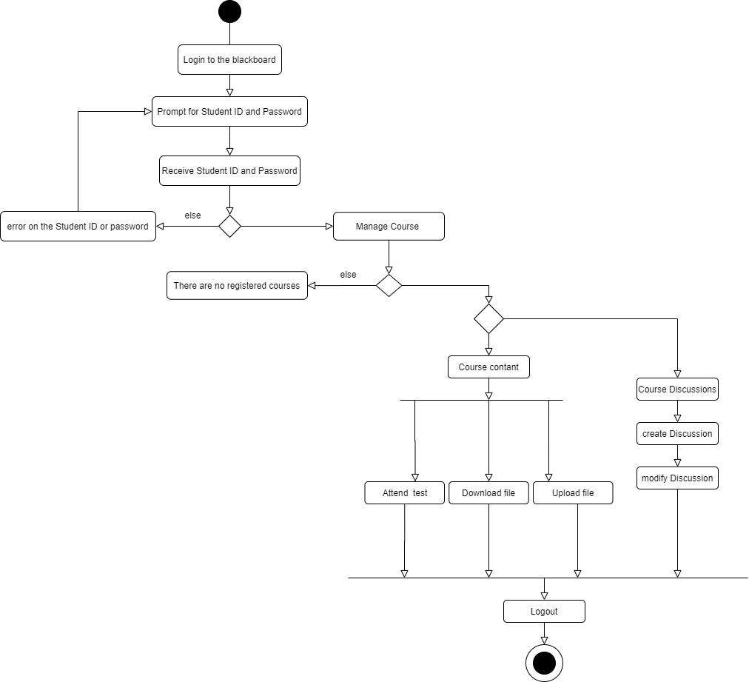

**Task 3**

(Total Marks = 02)

Draw the Deployment Diagram for Email System

